The Title Should Be in Title Case, Single Spaced, Times New Roman, Bold 14-point, Left-justified, with a Maximum of 300 Characters or 75 Words

First Author¹, Second Author² and Name Last-name^{1,3}

¹Affiliation of the first author, Department/Institution, City, State/Province, Country
²Affiliation of the second author, Department/Institution, City, State/Province, Country
³Department of Geology, B University, Denton, TX, United States.

The submission should be a condensed version of your presentation and include all significant findings. Write the text so that readers who are not specialists can appreciate the purpose of the study and understand the procedures and conclusions. The text, entirely written in English, should include a brief introduction and motivation of the study (background and objective), experimental procedures, main results, and conclusions. It is not necessary to divide the text into sub-sections, except for the References section.
Use single spaced, Times New Roman 12-point font, full-justified formatting, and between 200-800 words. Use italics for taxonomic terms; do not use underlines. Avoid individualized formatting and special typefaces. Do not indent the first paragraph but do indent all subsequent paragraphs. Indicate references within the text with Arabic numbers in square brackets, preferably at the end of the sentence, before the period [1]. Define all abbreviations at the first occurrence.
References are included at the end of the text, with the appropriate reference styles for journal articles [1, 2], preprints [3, 4], books [5-8], conference proceedings [9], and websites [10]. Indicate references within the text with Arabic numbers in square brackets, preferably at the end of the sentence, before the period. For references with three or more authors, use the first-named author followed by “et al.” Acknowledgements, statements regarding of the division of work, or disclaimers should be included in the last reference, which is cited at the end of the last sentence of the text.
All accepted papers must be presented by a meeting registrant. If the registrant cannot attend due to unforeseen circumstances, an alternate presenter should be arranged by the submitter or original presenter [11].
Figures and Tables should appear after text before the references. A maximum of two figures may appear in your submission (Figs 1 and 2). Include figure labels and scale markers on all figures. Captions should be placed below all figures and tables. Artwork and tables (Table 1) must be electronically inserted into the document. Color figures may be used and will be reproduced in any electronic proceedings distributed (Fig. 1 A, B, C). Paper copies might be in grayscale, so ensure that color coding used for legends is distinguishable in grayscale (Fig. 2). Check that the line widths and font sizes allow the figure to be clear at its final size. Consider accessibility when designing your figure(s), so that your images can be easily understood by color-blind and visually impaired readers. Figures are not mandatory but highly encouraged.

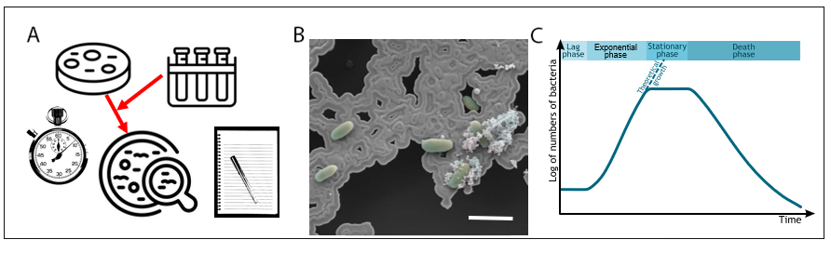
Fig. 1. Times New Roman, 12pt., left-justified. Provide a short description of the figure, including labels and scale markers as appropriate. Figures may have multiple panels, with each panel labeled with a letter (A, B, C.). Scale bar = 0.5 mm.

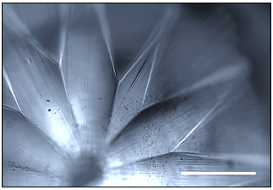

Fig. 2. Times New Roman, 12pt., left-justified. Provide a short description of the figure, including labels and scale markers as appropriate. Scale bar = 500μm.

Item | Value (units) | Value | Units
1
2
3
4

Table 1. All tables must be electronically incorporated into the document. You may use the table- making functions of your word processor to create the table with a horizontal line at the top and bottom and below the column headings. Indicate units (in parentheses) in column headings as needed. Type information single spaced within the table. Captions should be in single spaced, Times New Roman 12-point font, left-justified, start with “Table #.” in bold, and placed below their respective tables.

References:
1. Author FM and Author S. Journal (year) volume page-numbers. https://doi.org/10.000
2. Montero Llopis P et al. Nature Methods (2021) 18, 1463–1476. https://doi.org/10.1038/s41592-021-01156-w
3. Author FM and Author S. Server (year) server DOI suffix, preprint: not peer reviewed. https://doi.org/10.0000
4. Lopez Bernal J et al. medRxiv (2021) medRxiv 2021.05.22.21257658, preprint: not peer reviewed. https://doi.org/10.1101/2021.05.22.21257658
5. Author FM. Title of Book. City, state/province: publisher; year.
6. El-Mohtar A and Gladstone M. This is How You Lose the Time War. New York, NY: Saga Press; 2019.
7. Author FM in Title of Book, Editor TB (Ed.), City, state/province: publisher; year.
8. Akai S et al. in The Fungal Spore, Weber DJ and Hess WM (Eds.), New York, NY: John Wiley & Sons, Inc.; 1976.
9. Author FM and Author S. Conference Proceedings, year.
10. Title of website, http://www.examplewebsite.com (accessed Month Day, Year).
11. The authors acknowledge funding from the Prydonian Academy, X-File Department. Professor Monica Rambeau is thanked for her many useful discussions and contributions to this work. TSM acknowledges M&M proceedings editor for the reference text.

